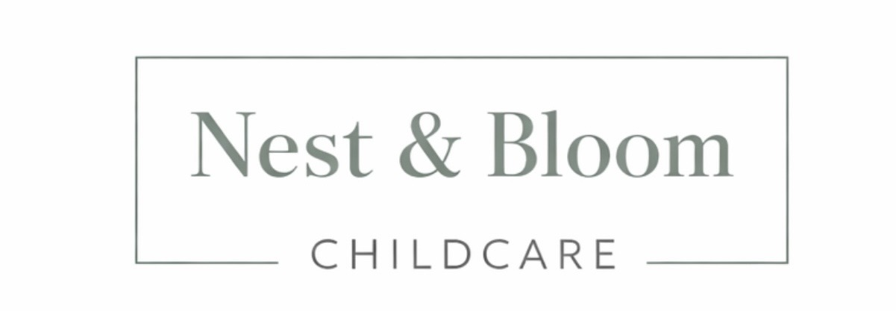
Privacy & Cookie Policy
Last Updated: March 2026
Registered in England and Wales

- Who We Are

Nest & Bloom Childcare Ltd ("we", "us", "our") is a professional nanny recruitment agency registered in England and Wales. We are committed to protecting your privacy and handling your personal data with care, transparency, and respect.
This Privacy and Cookie Policy explains how we collect, use, store, and protect your personal information when you use our website, enquire about our services, register as a nanny candidate, or engage us as a family client.
We are the data controller for the personal data we process. If you have any questions about this policy or how we handle your data, please contact us at hello@nestandbloomchildcare.co.uk.

- What Personal Data We Collect
From Families:
- Full name and contact details (email address, phone number)
- Home address and general location
- Details of childcare requirements (children's ages, hours needed, specific needs)
- Payment information (processed securely — we do not store full card details)
- Any other information you voluntarily provide when contacting us

From Nanny Candidates:
- Full name and contact details (email address, phone number)
- Home address and location
- CV and full employment history
- Qualifications and certificates (including Paediatric First Aid, childcare qualifications)
- Enhanced DBS certificate details and disclosure information
- Right to work documentation
- References from previous employers
- Any other information provided during the registration and interview process

From Website Visitors:
- IP address and browser information (collected automatically via cookies)
- Pages visited, time spent on site, and how you arrived at our website
- Any information submitted via our contact or enquiry forms

We only collect personal data that is necessary for the purposes outlined in this policy. We do not collect special category data (such as health or ethnicity information) unless it is directly relevant to a candidate's suitability for a role and you have given explicit consent.

- How We Use Your Personal Data

We use your personal data for the following purposes:

Purpose | Legal Basis
Providing our recruitment and placement services | Contract / Legitimate Interests
Verifying candidate suitability and conducting checks | Legitimate Interests / Legal Obligation
Sharing candidate profiles with prospective families | Consent / Legitimate Interests
Processing payments | Contract
Sending marketing emails and newsletters | Consent (you may opt out at any time)
Improving our website and services | Legitimate Interests
Complying with legal obligations | Legal Obligation

- Who We Share Your Data With

We do not sell your personal data to any third party under any circumstances.
We may share your personal data with:
- Prospective family clients candidate profiles are shared only for the purpose of introduction and only with the candidate's knowledge and consent
- Prospective nanny candidates family requirements may be shared to facilitate matching
- DBS checking services for the purposes of enhanced background checks
- Reference contacts as provided by the candidate
- Payment processors to securely process fees (e.g. Stripe or similar; we do not store full card details)
- Wix (our website platform) which processes limited data in accordance with their own privacy policy
- Meta (Facebook/Instagram) via social media pixels on our website, subject to your cookie consent
- Google Analytics for website analytics, subject to your cookie consent
- Professional advisers such as accountants or legal advisers, where necessary
- Law enforcement or regulatory authorities where we are legally required to do so

- How long we keep your data

We retain personal data only for as long as is necessary for the purposes for which it was collected:
- Family client data retained for 3 years from the date of last engagement, or as required by law
- Nanny candidate data retained for 3 years from the date of registration or last contact
- Unsuccessful candidate applications retained for 6 months then securely deleted
- Financial and payment records retained for 7 years in accordance with HMRC requirements
- Website analytics data retained in accordance with Google Analytics and Wix default retention settings

At the end of the applicable retention period, your data will be securely deleted or anonymised. You may request earlier deletion at any time — see Section 8 for your rights.

- Marketing Communications

We may send you occasional emails about our services, childcare tips, or updates relevant to Nest & Bloom Childcare Ltd. We will only do this if you have given us your consent to do so.
You can opt out of marketing communications at any time by:
- Clicking the unsubscribe link in any marketing email we send you
- Emailing us directly at hello@nestandbloomchildcare.co.uk

Opting out of marketing communications will not affect any service-related communications we need to send you in connection with a live placement or active engagement.

- Cookie Policy
What Are Cookies?
Cookies are small text files placed on your device when you visit a website. They help the website remember your preferences, understand how you use the site, and deliver relevant content and advertising.

What Cookies We Use

Cookie Type | Purpose | Can Opt Out?
Essential Cookies | Required for the website to function. Includes session management and security. Cannot be disabled. | No
Wix Analytics | Collects anonymous data about how visitors use the site to help us improve it. | Yes
Google Analytics | Tracks website usage including pages visited, time on site, and traffic sources. | Yes
Meta Pixel (Facebook / Instagram) | Used to measure the effectiveness of our social media advertising and to show relevant ads on Facebook and Instagram. | Yes
Preference Cookies | Remembers your settings and preferences on the website. | Yes

Managing Your Cookie Preferences
When you first visit our website, you will be shown a cookie consent banner giving you the option to accept or decline non-essential cookies. You can change your preferences at any time by:
- Clicking the cookie settings option in the footer of our website
- Adjusting your browser settings to block or delete cookies
- Using opt-out tools provided by Google (tools.google.com/dlpage/gaoptout) and Meta (facebook.com/settings)

Please note: disabling certain cookies may affect the functionality of our website and your experience when using it.

- Your Rights Under GDPR

Under the UK General Data Protection Regulation, you have the following rights regarding your personal data:
- Right of Access — you can request a copy of the personal data we hold about you
- Right to Rectification — you can ask us to correct any inaccurate or incomplete data
- Right to Erasure — you can ask us to delete your personal data in certain circumstances
- Right to Restrict Processing — you can ask us to limit how we use your data
- Right to Data Portability — you can ask us to transfer your data to another organisation
- Right to Object — you can object to us processing your data for marketing or on the basis of legitimate interests
- Right to Withdraw Consent — where processing is based on consent, you can withdraw it at any time

To exercise any of these rights, please contact us at hello@nestandbloomchildcare.co.uk. We will respond within 30 days. There is no charge for making a request.

If you are unhappy with how we have handled your personal data, you have the right to lodge a complaint with the Information Commissioner's Office (ICO) at ico.org.uk or by calling 0303 123 1113.

- How We Protect Your Data
We take the security of your personal data seriously and have appropriate technical and organisational measures in place to protect it against unauthorised access, loss, or disclosure. These include:
- Password-protected systems and devices
- Secure email communications
- Limiting access to personal data to those who need it to carry out their role
- Using reputable third-party platforms with strong security standards (Wix, etc.)
- Secure deletion of data at the end of retention periods

In the unlikely event of a data breach that poses a risk to your rights and freedoms, we will notify the ICO within 72 hours and inform affected individuals without undue delay.

- Third party Links
Our website may contain links to third party websites. This policy applies only to Nest & Bloom Childcare Ltd and our own website. We are not responsible for the privacy practices of any third party websites and encourage you to read their privacy policies before providing any personal information.

- Changes to this Policy
We may update this Privacy and Cookie Policy from time to time to reflect changes in our practices or legal requirements. The latest version will always be available on our website, and the date at the top of this document will be updated accordingly.
We encourage you to review this policy periodically. Where changes are significant, we will notify you directly by email where we hold your contact details.

- Contact Us
If you have any questions, concerns, or requests relating to this Privacy and Cookie Policy, please contact us:

Business Name | Nest & Bloom Childcare Ltd
Email | hello@nestandbloomchildcare.co.uk
Registered in | England and Wales
Supervisory Authority | Information Commissioner's Office (ICO) — ico.org.uk
Last Updated | March 2026

