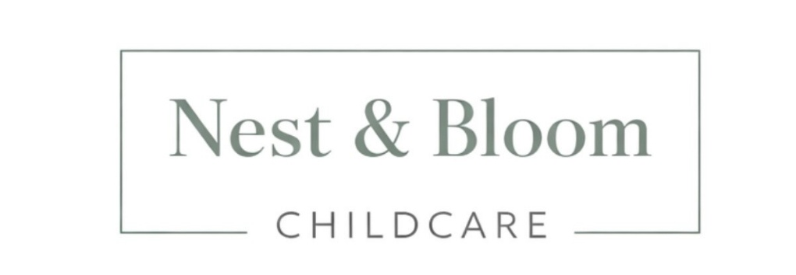
Nest & Bloom Childcare Ltd | Registered in England and Wales

TERMS AND CONDITIONS
Last Updated: April 2026
1. Introduction
Welcome to Nest & Bloom Childcare Ltd.
These Terms and Conditions ("Terms") govern your use of our services and form a legally binding agreement between Nest & Bloom Childcare Ltd ("we", "us", "our") and any individual or organisation engaging our services ("you", "client", "candidate").
By engaging our services — whether as a family seeking childcare or as a nanny candidate registering with us — you confirm that you have read, understood, and agree to be bound by these Terms.
We reserve the right to update these Terms at any time. Continued use of our services following any changes constitutes acceptance of the updated Terms.
2. Introduction Agency Status
Nest & Bloom Childcare Ltd acts solely as an introduction agency. We do not employ nannies or candidates and are not a party to any contract of employment entered into between a family and a candidate.
The family is solely responsible for all aspects of the employment relationship, including but not limited to compliance with applicable employment law, payment of wages, tax, National Insurance contributions, pensions, and any other statutory obligations.
3. Ofsted and Childcare Responsibility
Nest & Bloom Childcare Ltd is not a childcare provider and does not supervise or manage the day-to-day care provided by any nanny. Responsibility for the care of children rests solely with the family and the nanny.
We are not required to register with Ofsted as we act solely as a recruitment and introduction agency. Families should satisfy themselves as to any regulatory requirements applicable to their specific childcare arrangements.
4. Our Services
Nest & Bloom Childcare Ltd provides a bespoke childcare recruitment and placement service, connecting families with carefully vetted childcare professionals for permanent, temporary, and ad hoc roles.
Our services include, but are not limited to:
- Candidate sourcing, screening, and interviewing
- Enhanced DBS verification and reference checking
- Qualification and right to work document verification
- Matching candidates to family requirements
- Interview coordination between families and candidates
- Ongoing support during and after placement

All services are provided on a best-endeavours basis. While we take every care to match families with suitable candidates, we cannot guarantee that any particular candidate will meet a family's specific requirements.

5. Client Responsibilities — Families
By engaging our services, families agree to:
- Provide accurate, complete, and up-to-date information regarding their childcare requirements
- Conduct their own due diligence and interviews before making a hiring decision
- Verify the suitability of any candidate before employment commences
- Comply with all applicable UK employment laws, including issuing a written contract of employment, operating PAYE payroll, and meeting National Minimum Wage obligations
- Obtain and maintain appropriate insurance in relation to the employment of a nanny, including employer's liability insurance where required by law
- Provide a safe, appropriate, and lawful working environment
- Notify us promptly if a placement is not proceeding or if any concerns arise
- Not engage any candidate introduced by us directly without paying the applicable placement fee

Important: If a family engages a candidate introduced by Nest & Bloom Childcare Ltd — whether immediately or within 12 months of the introduction — the full placement fee becomes payable, regardless of whether our services were formally engaged at the time of hire.
6. Candidate Responsibilities — Nannies
By registering with Nest & Bloom Childcare Ltd, nanny candidates agree to:
- Provide truthful, accurate, and complete information at all times
- Disclose any relevant criminal convictions, cautions, or safeguarding concerns
- Maintain valid right to work documentation throughout their registration
- Hold a current Paediatric First Aid certificate or commit to obtaining one
- Act professionally and responsibly in all placements and communications
- Notify us promptly of any changes to availability, circumstances, or employment status
- Not approach or accept direct engagement from families introduced by us, bypassing our agency

Any misrepresentation of qualifications, experience, or personal circumstances may result in immediate removal from our database and, where appropriate, referral to relevant authorities.
7. No Guarantee of Placement
While Nest & Bloom Childcare Ltd endeavours to introduce suitable candidates, we do not guarantee the suitability, performance, or conduct of any candidate, nor do we guarantee that any placement will be successful or ongoing.
Families are responsible for conducting their own thorough interviews and checks before offering employment to any candidate introduced by us.
8. Fees and Payment
All fees are clearly communicated prior to engagement. Our fees are as follows:

Registration / Admin Fee: £150 — non-refundable, payable upon engagement of our services.

Placement Fee (Permanent or Long-Term): 12% of the nanny's agreed gross annual salary, payable within 7 days of the nanny's agreed start date.

Temporary Placement Fee: A fixed fee as agreed in writing prior to commencement, payable within 7 days of the nanny's agreed start date. Temporary placements of less than 8 weeks will be charged at a flat rate agreed at the time of placement.

Nanny Registration: Completely free — nannies are never charged any fee.

All fees are due within 7 days of the invoice date unless otherwise agreed in writing. Late payment may result in suspension of services and interest charges in accordance with the Late Payment of Commercial Debts (Interest) Act 1998.
9. Cooling Off Period
Where services are agreed at a distance, the client may have a statutory right to cancel within 14 days under the Consumer Contracts Regulations 2013.
By requesting that services commence within this 14 day period, the client acknowledges and agrees that the right to cancel may be lost once the service has been fully performed.
The non-refundable registration fee of £150 is payable upon engagement and is not subject to the cooling off right where the client has requested immediate commencement of services.
10. Trial Periods and Replacements
Where a trial period is agreed between the family and the nanny candidate, the duration and terms will be confirmed in writing prior to commencement. The full placement fee remains due and payable regardless of the outcome of the trial period.
Where a placement ends within 8 weeks of commencement and the family has complied fully with these Terms, Nest & Bloom Childcare Ltd will use reasonable endeavours to provide one replacement candidate free of further placement fee charge, subject to:
- Full payment of all outstanding fees, including the original placement fee and the non-refundable £150 registration fee
- Written notification of the placement ending within 7 days of termination
- Suitable replacement candidates being available on our books at the time

The £150 registration / admin fee is non-refundable in all circumstances, including during a replacement period.
11. Indemnity
The client agrees to indemnify and hold harmless Nest & Bloom Childcare Ltd from and against any claims, losses, liabilities, damages, or expenses arising out of or in connection with:
- (a) the employment or engagement of any candidate introduced by us
- (b) any act or omission of the candidate following introduction
- (c) any failure by the client to comply with applicable employment or legal obligations

This indemnity shall survive termination of the agreement between the parties.
12. Insurance Responsibility
The family acknowledges that it is their responsibility to obtain and maintain appropriate insurance in relation to the employment of a nanny, including but not limited to employer's liability insurance where required by law.
Nest & Bloom Childcare Ltd accepts no liability for any loss arising from a failure to obtain appropriate insurance cover. We strongly recommend families seek independent advice regarding their insurance obligations before a nanny commences employment.
13. Confidentiality
All information shared between Nest & Bloom Childcare Ltd, families, and candidates must be treated as strictly confidential. You agree not to share candidate profiles, personal details, or documentation with any third party without our prior written consent, and not to circumvent Nest & Bloom Childcare Ltd by engaging candidates introduced by us directly.
Breach of confidentiality may result in immediate termination of our services and legal action to recover any losses suffered, including unpaid placement fees.
14. Data Protection
Nest & Bloom Childcare Ltd processes personal data in accordance with the UK General Data Protection Regulation (UK GDPR) and the Data Protection Act 2018. By engaging our services, you consent to the collection, storage, and use of your personal data as outlined in our Privacy and Cookie Policy, available on our website at nestandbloomchildcare.co.uk.
15. Safeguarding
Safeguarding the welfare of children is at the core of everything we do. While we conduct thorough vetting checks including enhanced DBS verification, reference checks and personal interviews, we do not guarantee the future conduct of any candidate following placement. Families are responsible for ongoing supervision and maintaining appropriate safeguarding standards within their home.
Any safeguarding concerns must be reported to the relevant authorities immediately.
16. Compliance with Agency Regulations
Nest & Bloom Childcare Ltd operates in accordance with the Conduct of Employment Agencies and Employment Businesses Regulations 2003.
We undertake reasonable steps to obtain and verify candidate information, including identity, right to work in the UK, qualifications, and references. While we take all reasonable care in these checks, we do not warrant or guarantee the suitability of any candidate.
17. Limitation of Liability
To the fullest extent permitted by law, Nest & Bloom Childcare Ltd shall not be liable for any loss, damage, injury, or claim arising directly or indirectly from the placement of a candidate or the conduct of any candidate following placement. Our total liability shall not exceed the value of the fees paid to us in respect of the relevant placement.
Nothing in these Terms limits our liability for death or personal injury caused by our negligence, fraud, or any other liability that cannot be excluded by law.
18. Termination
We reserve the right to suspend or terminate our services immediately if these Terms are breached, false or misleading information is provided, there are safeguarding concerns, or payment obligations are not met.
You may terminate your engagement with us at any time by providing written notice. Termination does not affect any fees already due or obligations already incurred.
19. Complaints Procedure
Nest & Bloom Childcare Ltd is committed to providing a high standard of service. If you are dissatisfied with any aspect of our service, we want to hear from you.
Any complaints should be submitted in writing to hello@nestandbloomchildcare.co.uk. We will acknowledge receipt within 5 working days and aim to respond fully within 14 working days.
If you remain dissatisfied following our response, you may escalate your complaint in writing and we will conduct a further review. We are committed to resolving all complaints fairly and promptly.
20. Governing Law and Disputes
These Terms and Conditions are governed by and construed in accordance with the laws of England and Wales. Any dispute arising from or in connection with these Terms shall first be referred to mediation in good faith. If mediation is unsuccessful, disputes shall be subject to the exclusive jurisdiction of the courts of England and Wales.
21. Contact Us
If you have any questions regarding these Terms and Conditions, please contact us:

Business Name: Nest & Bloom Childcare Ltd
Email: hello@nestandbloomchildcare.co.uk
Website: nestandbloomchildcare.co.uk
Registered in: England and Wales
Last Updated: April 2026

AGREEMENT & SIGNATURE
By signing below, both parties confirm they have read, understood and agreed to the Terms and Conditions of Nest & Bloom Childcare Ltd set out above.
CLIENT (Family)  Full Name (Print)  Signature  Date  Address | NEST & BLOOM CHILDCARE LTD  Full Name (Print)  Arthi Kaur  Signature  Date  2026  Position  Director

Nest & Bloom Childcare Ltd | nestandbloomchildcare.co.uk | hello@nestandbloomchildcare.co.uk | 07590594461

